**Data tool for the Safe Routes to School part of the Montgomery County Safe Streets Act**

Miriam Schoenbaum

Data 205 Capstone Experience in Data Science

December 15, 2023

**INTRODUCTION**

This project was prompted by passage of the Montgomery County Safe Streets Act on September 27, 2023. The law will go into effect on July 1, 2025. One of its provisions, related to Safe Routes to School, requires the Montgomery County Department of Transportation to conduct a infrastructure review for every crash that meets the following criteria:

* a police crash report involving a non-motorist (of any age),
* on a road controlled by the county, AND
* in a county-established “school zone”, OR
* within a designated school walk zone between 7 am and 9 pm on a school day, OR
* at a school bus stop (upon notification by MCPS).

**OVERVIEW OF PROJECT PLAN**

***Datasets***

The datasets used were:

* Data Montgomery crash open data (Non-motorist and Incident datasets)
  + Posted at <https://www.montgomerycountymd.gov/visionzero/data.html>
  + Updated every Friday
* Maryland State Police crash data download (non-motorist date of birth and sex)
  + Posted at <https://mdsp.maryland.gov/Pages/Dashboards/CrashDataDownload.aspx>
  + Updated daily
* Montgomery County Public Schools 2021-22 walk zones and school bus stop locations
  + Not publicly posted
  + Obtained through a Maryland Public Information Act request
* School zones established by the Montgomery County Department of Transportation
  + Not publicly posted
  + Obtained through a request to the Montgomery County Vision Zero Coordinator

***Tools***

The tools used were:

* R and R Studio
* ArcGIS Pro (individual license)
* Excel

***Goals***

The goals of the project were to answer two questions:

* What are some important characteristics of crashes in Montgomery County where drivers hit non-adult (aged 0-18) non-motorists (pedestrians, bicyclists, etc.)?
* How many crashes might require infrastructure reviews by the Montgomery Department of Transportation, under the Safe Routes to School provision of the Safe Streets Act, when the law goes into effect on July 1, 2025?

**CLEANING/WRANGLING THE DATA**

Very little data cleaning was done, on grounds that the data are what they are. For data wrangling, the major steps were:

* Combining the two Data Montgomery datasets using the Report Number field;
* Combining the Data Montgomery data with the Maryland State Police crash data using the NonMotoristID field;
* Creating 100-foot buffers around school zones and school bus stop locations in ArcGIS Pro;
* Identifying the crashes with locations in the areas of interest (school zones, school bus stop locations, walk zones) in ArcGIS Pro.

Data wrangling also included reclassifying variables as factors, creating categorical variables for analysis, and removing unneeded variables.

**SUMMARY OF DESCRIPTIVE STATISTICS**

Findings from the exploratory data analysis include:

* The age distribution of non-motorists in police reported crashes is skewed to the left, i.e., younger people are over-represented.

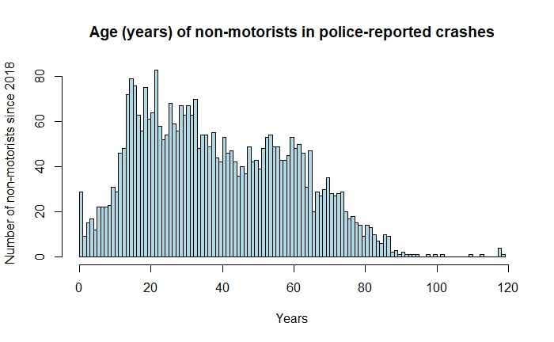

* Non-adult non-motorists are more likely than adult non-motorists to have been using small things with wheels (bicycles, skateboards, scooters, strollers, wheelchairs) when hit by a driver.

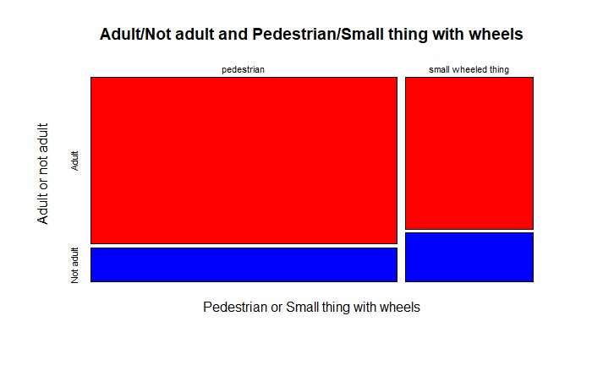

* Taking other significant factors into account, a logistic regression model finds that police are about 50% more likely to find the non-motorist at fault when a driver hits a non-adult non-motorist, compared to an adult non-motorist.

|  |  |
| --- | --- |
| **Police MORE likely to find**  **non-motorist at fault** | **Police LESS likely to find**  **non-motorist at fault** |
| Driver did not hit & run | Driver hit & ran |
| Non-motorist is non-adult (0-18) | Non-motorist is adult (19+) |
| Non-motorist had serious or fatal injury | Non-motorist had “minor”, “possible”, or no injury |
| Crash happened at night (9 pm - 7 am) | Crash happened during the day (7 am - 9 pm) |
| Crash happened on road | Crash happened off road (e.g., parking lot) |
| Non-motorist is male | Non-motorist is female |

* Even for non-motorists who were hit by drivers in a crosswalk or on a sidewalk, and who did not disobey a signal, police were more likely to find the non-motorist at fault if the non-motorist was a non-adult, compared to an adult.

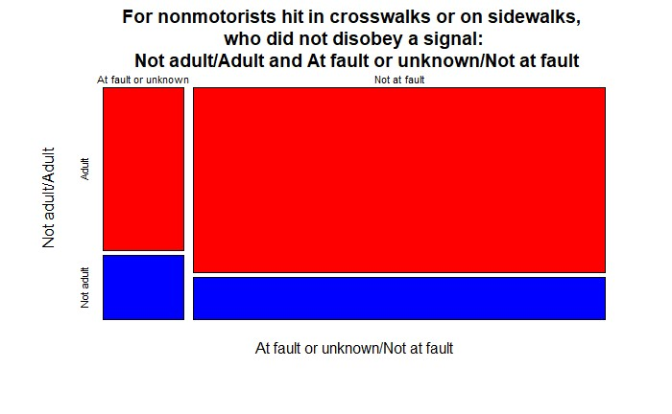

**DESCRIPTION OF THE FINAL DATA PRODUCT**

***Summary of creation of the final data product***

The production steps were:

* [R webscraping file (R Selenium package): read in MSP crash data. Unfortunately, while I got the driver set up, I couldn’t get the driver to do what I wanted it to do.]
* R Markdown file 1: read in, wrangle, and merge crash data; do EDA and inferential data analysis; create first output file for spatial processing
* ArcGIS Pro file: run model to identify non-motorists hit in walk zones, school zones, school bus stops; create second output file for further analysis and processing
* R Markdown file 2: read in and wrangle ArcGIS Pro output file; create Safe Routes to School file

***How the data product achieved the goals***

* The first output file can be used to answer the first question (important characteristics of crashes in Montgomery County where drivers hit non-adult (aged 0-18) non-motorists).
* The second output file and Safe Routes to School file can be used to answer the second question (how many crashes might require infrastructure reviews when the Safe Streets Act goes into effect on July 1, 2025).

|  |  |  |
| --- | --- | --- |
| Safe Routes to School criteria | 2018-2023 to date | 2023 to date |
| School zone | 202 | 46 |
| School bus stop | 139 | 30 |
| Walk zone | 736 | 136 |
| Total | 873 | 162 |

***How the data product will be of value***

The data product will be of value to advocates for safe routes to school. It is also potentially of value to the Montgomery County Department of Transportation, which will be responsible for the infrastructure reviews, and to the Montgomery County Vision Zero Coordinator.

***The final product***

Examples of the first output file (datatable.csv), second output file (outputfile.csv), and Safe Routes to School file (SRTStable.csv) are in my GitHub repository.

***Reproducibility of the final product***

The final product is reproducible by anyone with access to my GitHub repository and ArcGIS.

**DATA STORY**

The data story is in my GitHub repository (final presentation and data story.pdf).

**OVERALL EXPERIENCE WITH DATA SOURCE**

***Pros***

* Data Montgomery is an amazing resource, and many localities don’t have anything like it.
* The Montgomery Planning Department is a wonderful resource for geospatial data.
* In many places, police crash data are secret, even though crashes are an important public safety issue.

***Cons***

* It is not easy to get data out of Montgomery County Public Schools.
* Crash data reports do not have enough information about non-motorist actions and infrastructure.
* Ideally, police crash reports would be reviewed for data accuracy and consistency.

**RECOMMENDATIONS**

* The Maryland State Police crash data site should retain all of the data they have posted, not just the current year and previous 5 years.
* The Maryland State Police crash data site should provide data files that are downloadable by API.
* The Data Montgomery crash data should include age and gender.
* Montgomery County Public Schools should publicly post school walk zone maps and spatial data files.
* The National Highway Traffic Safety Administration should include more complete data about non-motorist actions and infrastructure in the Model Minimum Uniform Crash Criteria (currently being revised).

**ACKNOWLEDGEMENTS**

Thank you to Data Montgomery; the GIS team and the Pedestrian Master Plan team at the Montgomery Planning Department; the safe-streets advocates at Action Committee for Transit, Montgomery County Families for Safe Streets, and the Washington Area Bicyclist Association; the faculty and students in my Montgomery College Data Science and GIS classes, and the Montgomery County Council and County Executive for passing and signing the Safe Streets Act.